Short design document for the new student theses repository front-end
By Ashley Hemerik – 10-01-2023

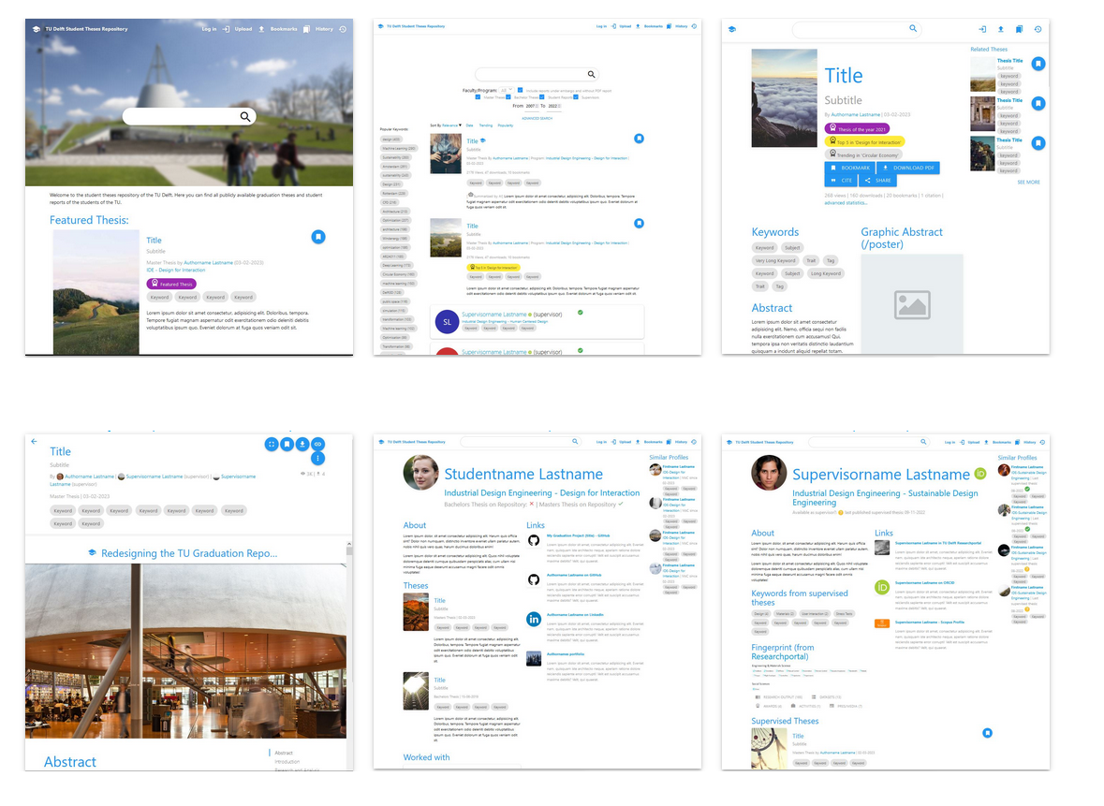
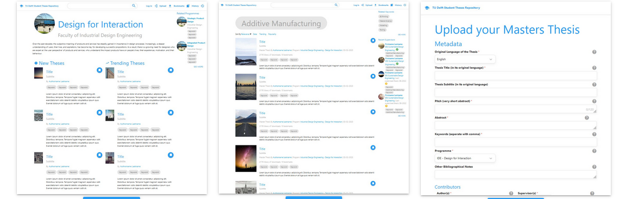

Introduction
I’ve been redesigning the student theses repository for the last half year for my graduation project. This documents walks you through the design considerations and decisions I’ve made; the results of my research into the users of the repository; and the importance of the features.

Resources
The interactive prototype can be found at
https://ashleyhemerik.github.io/Prototype%202/

A video of me walking through the digital prototype and explaining my design decisions
https://ashleyhemerik.github.io/Images/HTML%20prototype%20Walkthrough%20Compressed.mp4
The source code for my report and prototype can be found at
https://github.com/AshleyHemerik/AshleyHemerik.github.io
My graduation report can be found at https://ashleyhemerik.github.io
My latest contact information will be on my portfolio website https://ashleyhemerik.nl/

Who uses the student theses repository?
The student theses repository is mostly used by:
- ‘Orienting students’, who haven’t started their graduation projects yet, but they’re looking into what a graduation project might look like, what subjects they might be interested in, and what supervisors they might like. They want exemplary reports for their masters programme/topic.
- ‘Benchmarking students’, who are currently busy with their graduation projects. They’re looking at similar topics and reports to theirs, so that they can compare, get inspired, and see what’s expected of them. They want exemplary reports for their masters programme/topic.
- ‘Reporting students’, who are writing their report, and want to convey information. The repository must support their needs as best as possible via multimedia support.
- ‘Uploaders’, who have to go through the upload process during a very stressful period. The design needs to help them feel less anxious with clear communication and a transparent process.
- ‘Targeted downloaders’, who know exactly what report they want to download. They want to get to it quickly, hit download, and leave again.
- ‘Alumni’, who want their repository entry to be something they can be proud of, and have control over what information of them is on the website after they’ve graduated.
- ‘Supervisors’, who want to show off their supervisees’ works.
- ‘Headhunters’, are rare, but also use the repository. They want to find recent graduates from certain masters programmes, or supervisors.
- ‘Researchers’, often use external search engines like google scholar, but do happen upon the repository. Abstracts, keywords, quick downloads, and reports similar in topic are important to them.

New features by importance

Must Have:
- (Thesis previews) Views and download statistics
- (Thesis preview) Reports that require login to access
- (Thesis preview) Embargo warning
- (Homepage) [New/Trending/Top] in [Keyword/Programme]
- (Search page) sort by [New/Trending/Top]
- (Search page) Filter by Faculty/programme
- (Search page) Quick filter for include reports under embargo
- (Search page) Advanced search function
- Supervisor Profile
- (Entry page) Related Theses
- (Author/supervisor profile) Similar Profiles
- (Entry page) Takedown Request
- (Entry page) Graphic abstract/poster
- (Entry page) video support
- (Entry page) image support
- (Entry page) iFrame support
- (Entry page) Downloadable files section for all files (including unembedded types)
- (Entry page) Audio file support
- (Entry page) Links
- (Entry page) Large on-site PDF reader
- (Entry page) Author profile card
- (Entry page) Supervisor profile card
- (Supervisor profile) Supervision availability
- (Programme page) Available prolific supervisors for this programme
- (Programme page) [New/Trending/Popular] theses
- (supervisor profile) supervisor notes on supervised theses
- (supervisor profile) supervised programmes
- (supervisor profile) supervised theses
- (supervisor profile) Links
- “View more” for all collections

Should have
- (Homepage) Featured Thesis
- (Thesis previews) Prize chips next to keywords
- (Thesis previews) Pitches (new metadata: 1 or 2 sentence abstract)
- (Thesis previews) Automatically generated pitches with machine learning
- Full-website entries
- Programme Profile
- Keyword Profile
- (Homepage) Awards section
- History
- (Entry page) Cite Button
- (Entry page) 3D model viewer support
- (Programme page) Often used keywords in programme
- (Programme page) Related programmes (from the same faculty)
- (Programme page) Recent graduates
- (supervisor profile) Link to their research.tudelft.nl profile

Could have
- The bookmark system
- (Entry page) advanced view and download statistics
- (Search page) Include supervisors in search results
- Author Profile
- (Entry page) Share button
- (Entry page) bibliography
- (Entry page) Map preview (google maps widget)
- (Entry page) advanced report statistics
- (Author profile) worked with
- (supervisor profile) Related keywords

Changes to the system

Multimedia
The new system should support the use of different types of media and filetypes to the thesis entries, as multimedia reporting can enable better explanations from the writer, increase interactivity, and be more inspiring, and more understandable to the reader.
Classic formats such as video, images, and audio files should be able to be played within the website of the repository itself. Iframes and embeds from other websites can provide an infinite amount of interactivity to the reader (like 3D model viewers from sketchfab, map widgets from google maps, CAD viewers, code compiler widgets, etc.). Files that aren’t supported can be shown in a download section, which readers can then download for themselves, and play around with, look at source code, or recreate the experiments themselves, and much more. A section for links that have something to do with the project can provide a lot of value to the reader as well.
Media can also be extracted from already uploaded theses. PDF link and image extractors already exist, if these are applied automatically to the current repository, it can make the entry pages for theses theses a lot more interactive. Links to images and videos can already show the image or video on the page as well.
Other ideas for interactive multimedia include:
- more interactive PDF viewers (like issuu)
- website-as-report support (instead of PDF)
- embedding the file viewer widget from the TU dataset repository
- bespoke embedded 3d applications (like with Three.js)
- integrated 3D model and/or compiler support (as opposed to doing it via iframes from other people’s websites)
- autogenerated wordclouds
- summarizing abstracts into shorter ‘pitches’ with AI
- showing the coordinates currently in the PURE system on a google maps widget.

Popularity and prizes
Students reported wanting to see theses of quality to get inspired by. There are many good reasons why we don’t put the grades that the theses got on the repository, but some indication of quality is needed. I believe that popularity, based on views, downloads, and how a thesis has been bookmarked. This can be turned into a numerical value, which can then be used for searching. With this information, users could sort theses by date, popularity, or trending. The latter would include theses that have recently gotten a lot of views and downloads, so these would be recent good theses, or recently relevant good theses.
A manual approach to this should also be used. Some faculties, like IDE, give out prizes for best thesis of the year. These theses could be featured on the front page.
Featured theses, popular theses, and trending theses could receive a badge to indicate that they are likely of high quality, which could help readers explore the repository without feeling lost.

Supervisors
Supervisors play a big role in the graduation project world. Students might like to find a supervisor that specializes in their field of interest, and know if they’re available for supervision; supervisors might want to show off their supervised alumnus’ work and comment on it publicly; headhunters might want to get in contact with alumni that worked with a certain specialist in a field.
For this reason, it is important that supervisors get a profile page on the repository website. Their ORCID can be used to link their data from other TU websites to get up-to-date information from multiple sources on their page, so that readers know what these supervisors are about. Whether or not they are available for supervision can be confirmed by their department’s secretariat, or by the supervisor themselves, it can also be estimated based on how long ago a thesis that has been supervised by them was uploaded to the repository.

Privacy and what to do now that we can no longer force people to publish.
We can no longer force students to publish their thesis to the repository, but they are still required to archive their thesis, which means that they will have to go through the upload process anyway. This means that we need to encourage students to publish their work as much as possible. The reasons why someone might not want to publish their work is because of privacy concerns in the future, or because they’re not proud of it.
The privacy concerns can be addressed by making it clear that after they’ve published their thesis, it will be easy for them to take it down again. A ‘takedown request’ button needs to be displayed on every thesis entry, and the fact that it’s there needs to be told to the user at the end of the upload process. Another option is to allow the student to only have their thesis publicly available for a couple of years.
Students who are not proud of their work might not want everyone to be able to find their work, but they may feel like it’s okay to share it with other TU students whom it might help with theirs. A choice must be given at the end of the upload process:
- publish it for everyone.
- publish it for everyone, but don’t make it show up on search engines.
- publish it only for TU students and personnel (who are logged in with a NetID).
- don’t publish it.

Design considerations by page

Homepage
Following the principals of modern webdesign, navigation is placed in the top bar. The search bar is very prominently displayed, as most people will want to start searching right away when they get to this page. People who scroll past the search bar will want to know what the website is about, or get to see interesting theses at a glance, which is why there’s a short introduction below the ‘hero image’, and the featured thesis is prominently displayed. If the user wants to scroll further, they might want to see things more tailored to their specific tastes, which is why the [new/trending/top] in [faculty/programme/keyword] sections are there. The quick interaction of two dropdown menus gives the user enough freedom and specificity at this stage, as they still might be exploring and not knowing what they’re looking for, but they can quickly select what they’re interested in from a premade list.
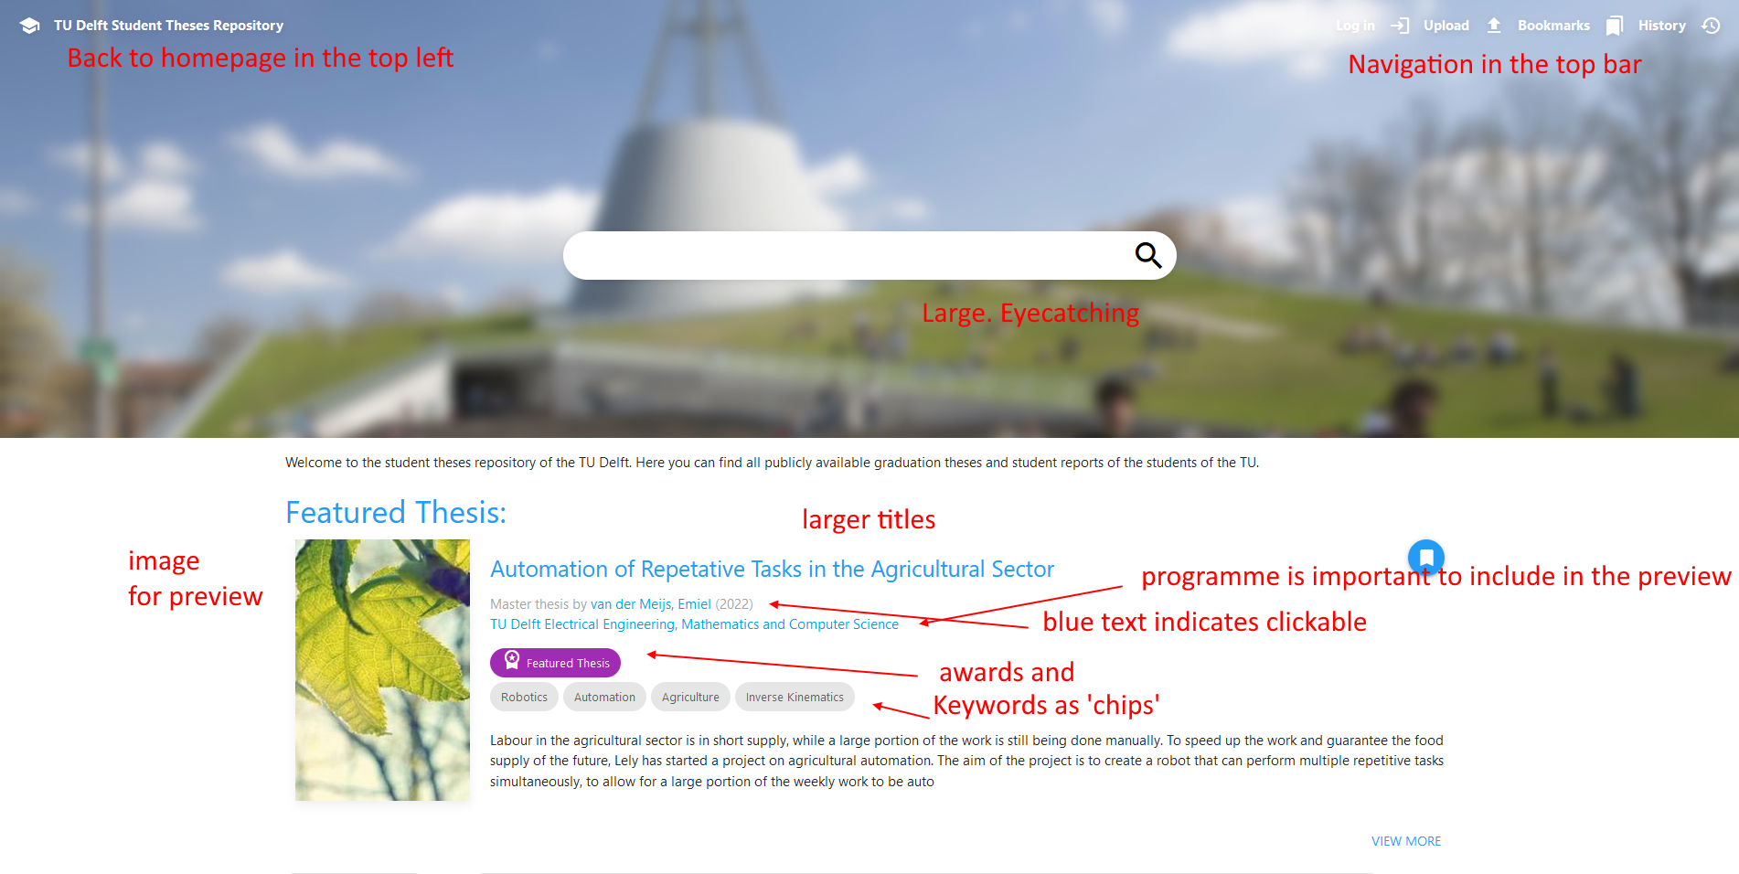

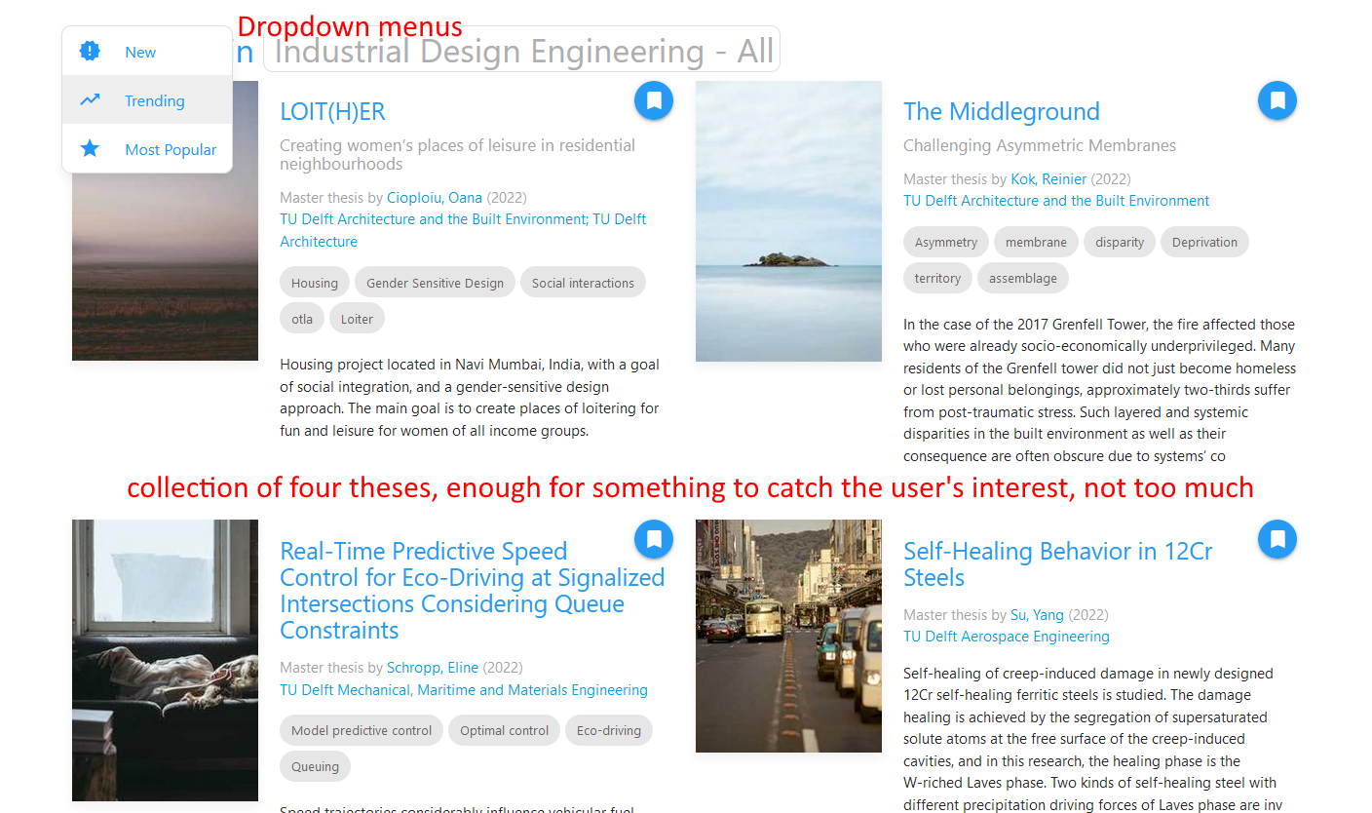
Thesis previews
The inclusion of a cover image is essential in grabbing attention and allowing the reader to decide if they’re interested in a split-second. This is also the reason for the large blue titles. The keywords are shown in the form of rounded rectangles, this indicates that they could be interpreted as ‘tags’, and are likely clickable if you want to see more theses with this keyword. Prizes are also in this form, and are either purple for the featured thesis, gold, silver, or bronze. Report type, author, date, and programme are shown.
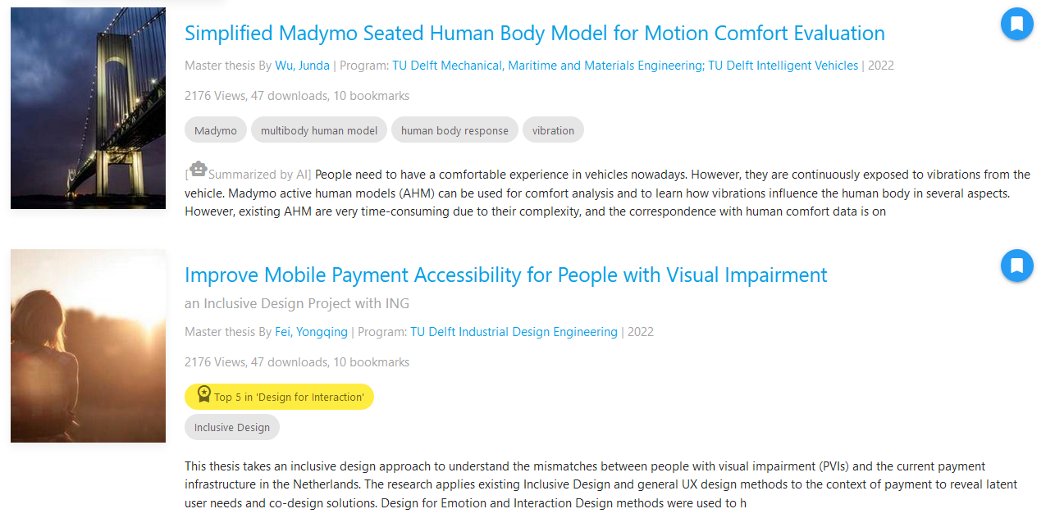
The description of the thesis should be a shortened version of the abstract, about 2 sentences long. I call this a ‘pitch’. That way, the entirety of the summary can be shown concisely in a preview. These can be automatically generated for the older theses using artificial intelligence ( try it here https://quillbot.com/summarize ), and should be filled in during the upload process from now on.

The bookmark system
The bookmark system allows users to save thesis entries to read them for later. It’s important that this system is very unobtrusive, and can be used by people who haven’t logged in as well. Bookmarks can be saved to cookies for users who are not logged in, and to both cookies and account data for logged in users.
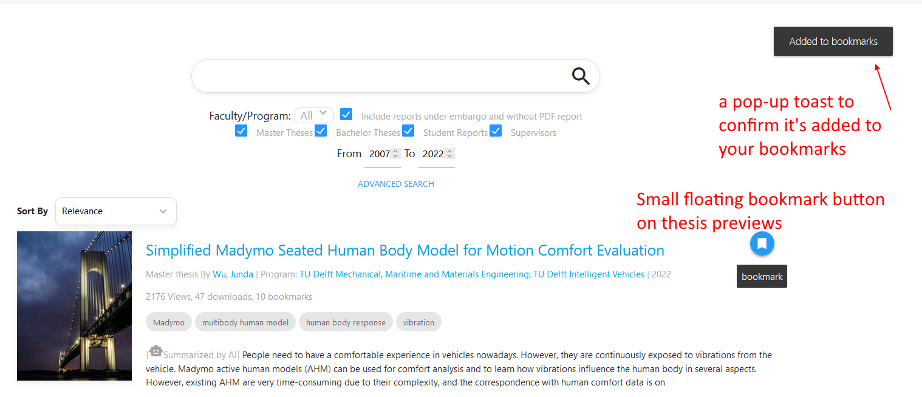

Search page

The two biggest changes from the old version here are quick, often used filters right under the search bar, the addition of an advanced search window, and the option for users to sort by relevance, trending, date, and total popularity. I’ve experimented with supervisor previews in the search results as well. If a supervisor has something to do with the search query, they could show up in the search results. Another important addition is the way of displaying the embargo state of a thesis in its preview, and how a thesis that’s
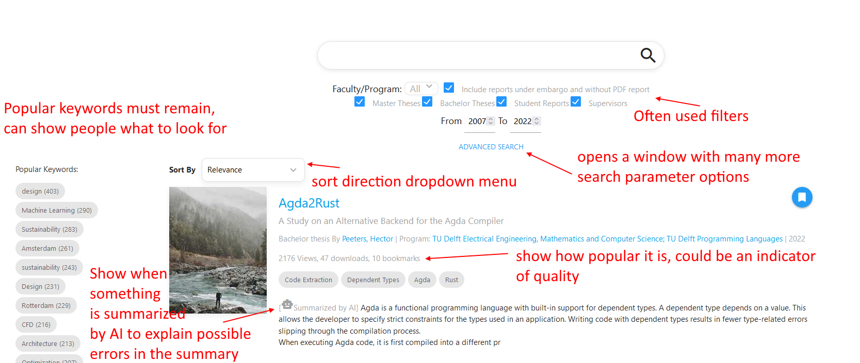
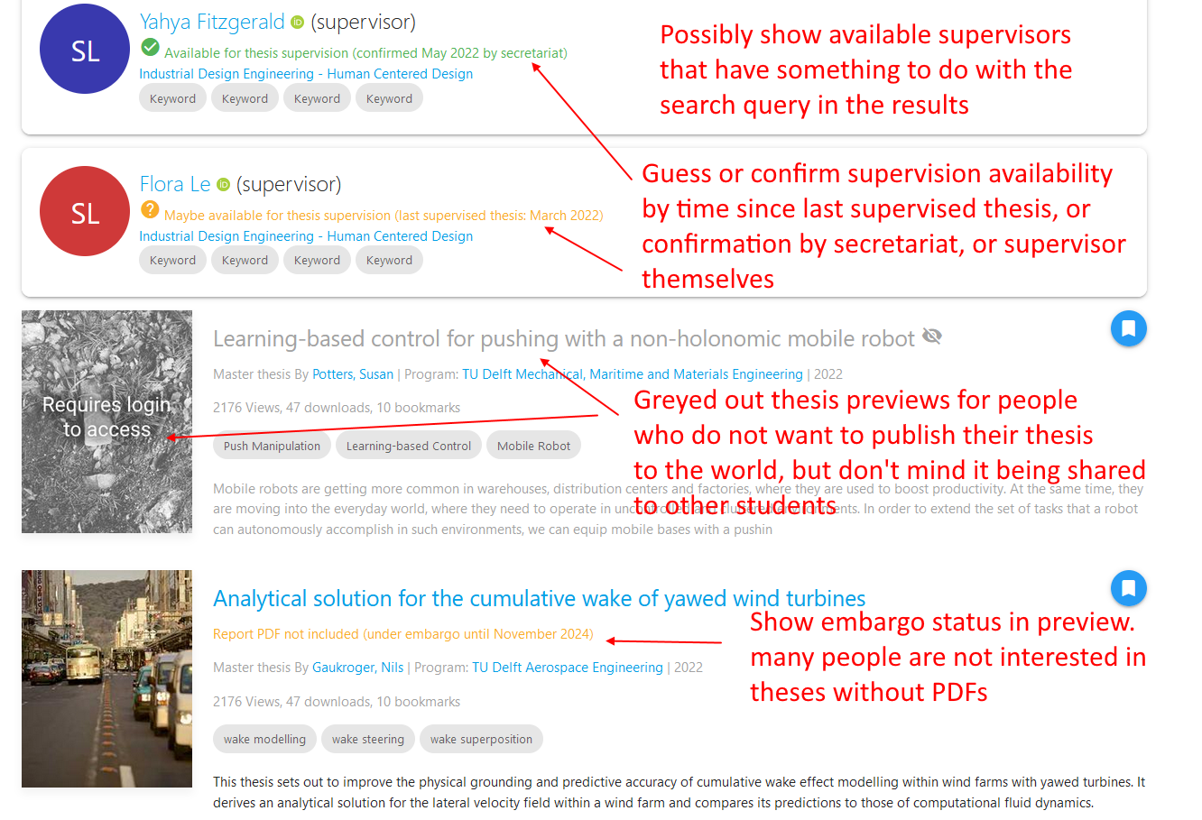

Entry page

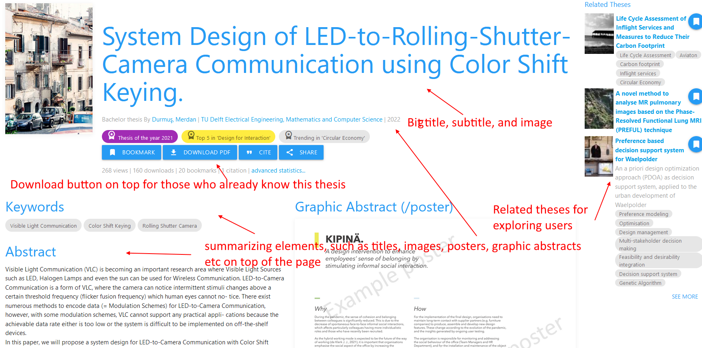
The goal of the entry page is to provide the reader with enough information for them to quickly assess quality and if they’re interested, and to quickly gain understanding of the subject of the thesis; to encourage further reading and provide jumping-off points for them to learn more about the subject; and to inspire, and provide ways for the user to interact with the subject. The entry page must also cater to the users’ specific needs, such as a quick download button for the ‘targeted downloaders’, in-depth information for the ‘benchmarking students’, supervisor profile cards for the ‘exploring students’, etc.. The entry page will contain viewers and widgets for all the content that the uploader has provided, such as images, audio files, videos, 3D models, downloadable files, related links, etc.

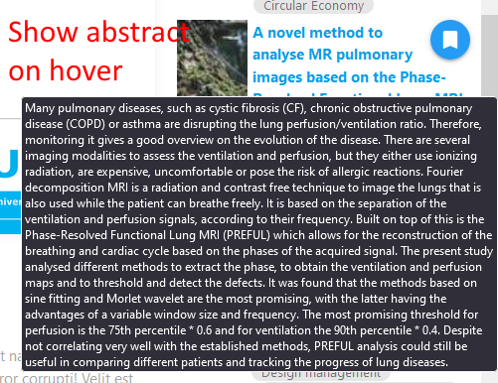

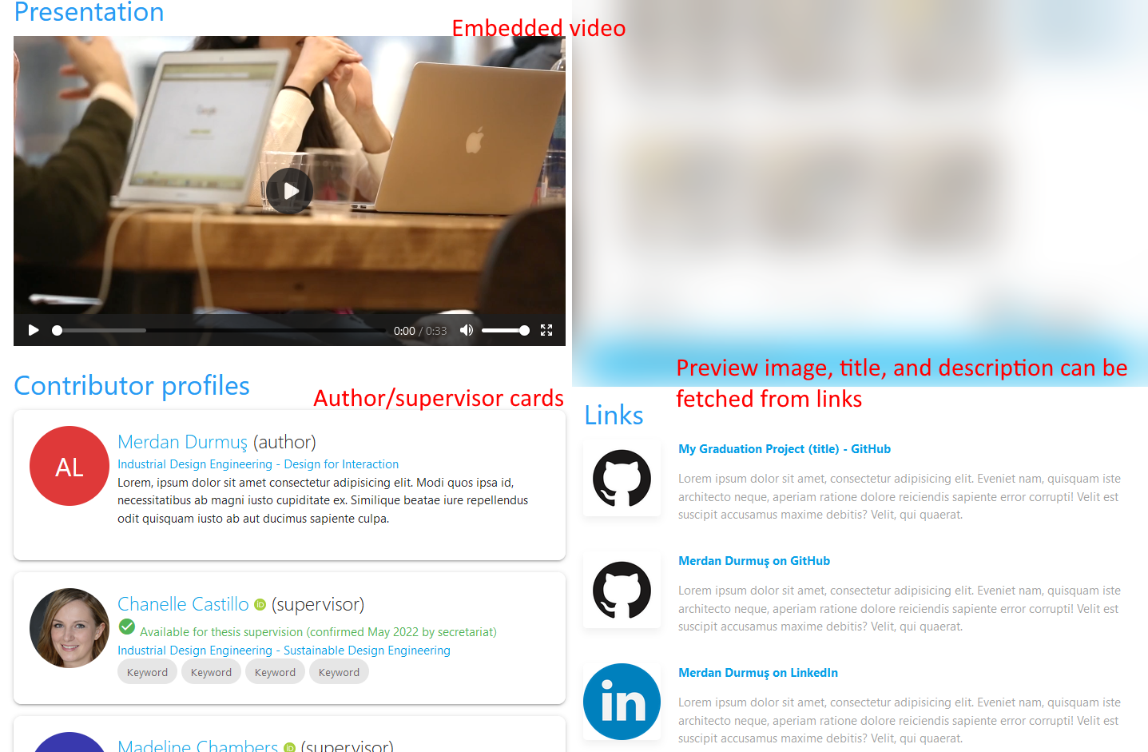
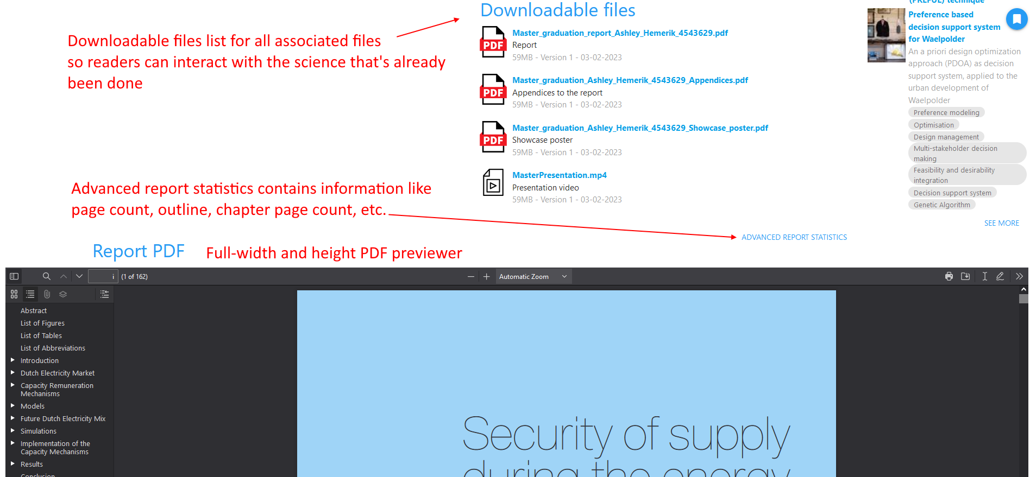

Full-website-report entry page

When using a website as a report, all the interactive and multimedia elements can be included into the report itself, which means that the front-end of the repository needs to do less work. It only needs to show its metadata and provide interactions such as ‘download’ and ‘share’ etc. The repository front-end should take a backseat here and be minimally invasive.

Full website reports should still have a zipped archive of all the websites assets available for download so people can still view the report in its (mostly) original fashion when it’s no longer on a webserver.
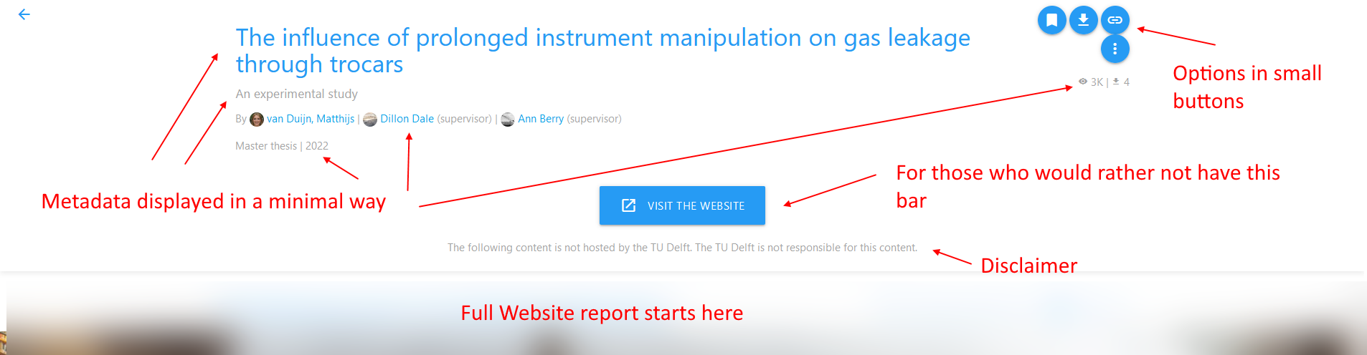

Supervisor profile page

Supervisors want to show off all the alumni they helped graduate, and their projects. Exploring students want to find available supervisors who are experts in the fields they are interested in, so that they may approach them to be their supervisor for their projects.

The following elements might help these users.
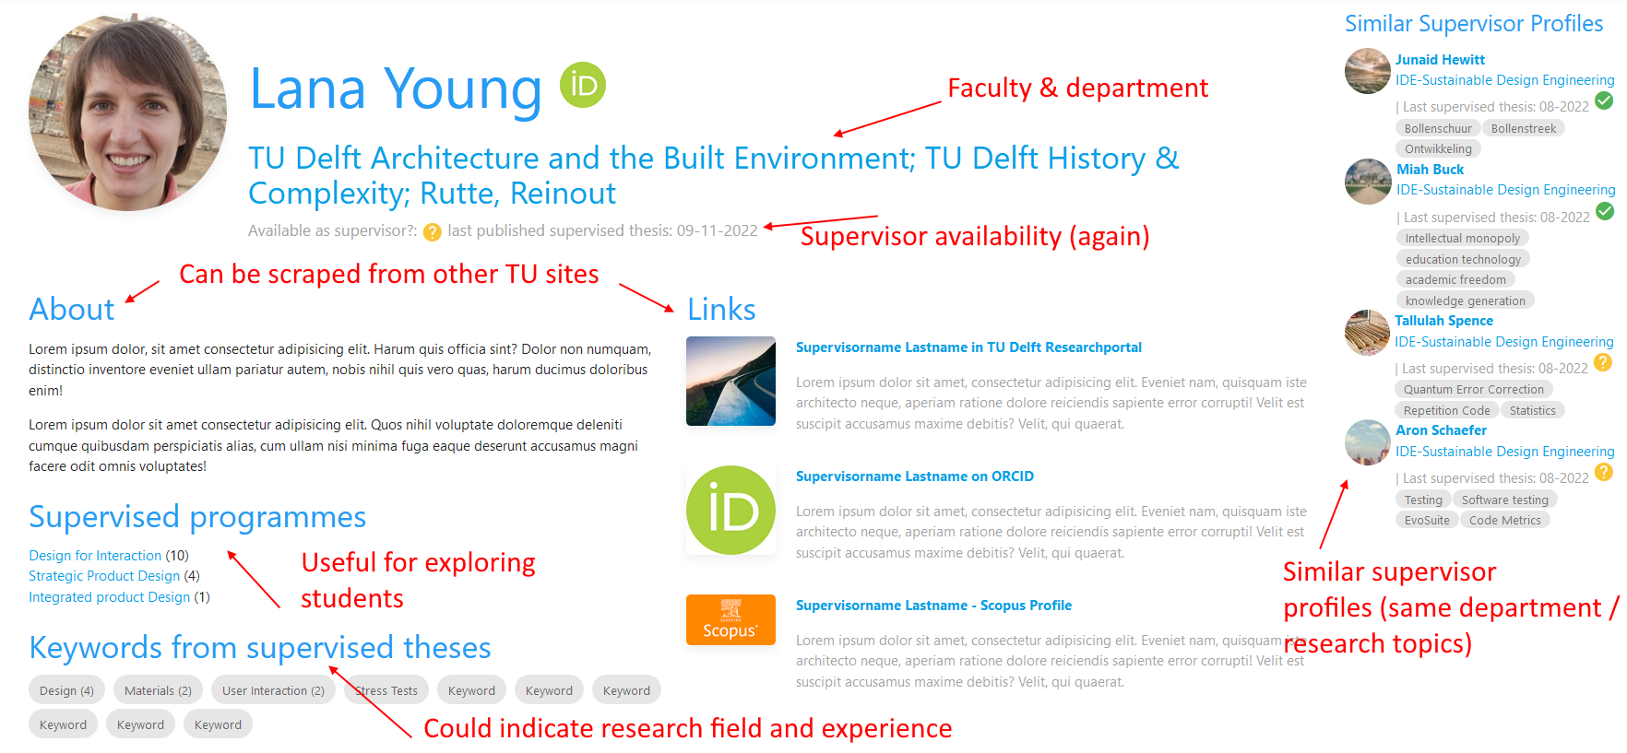
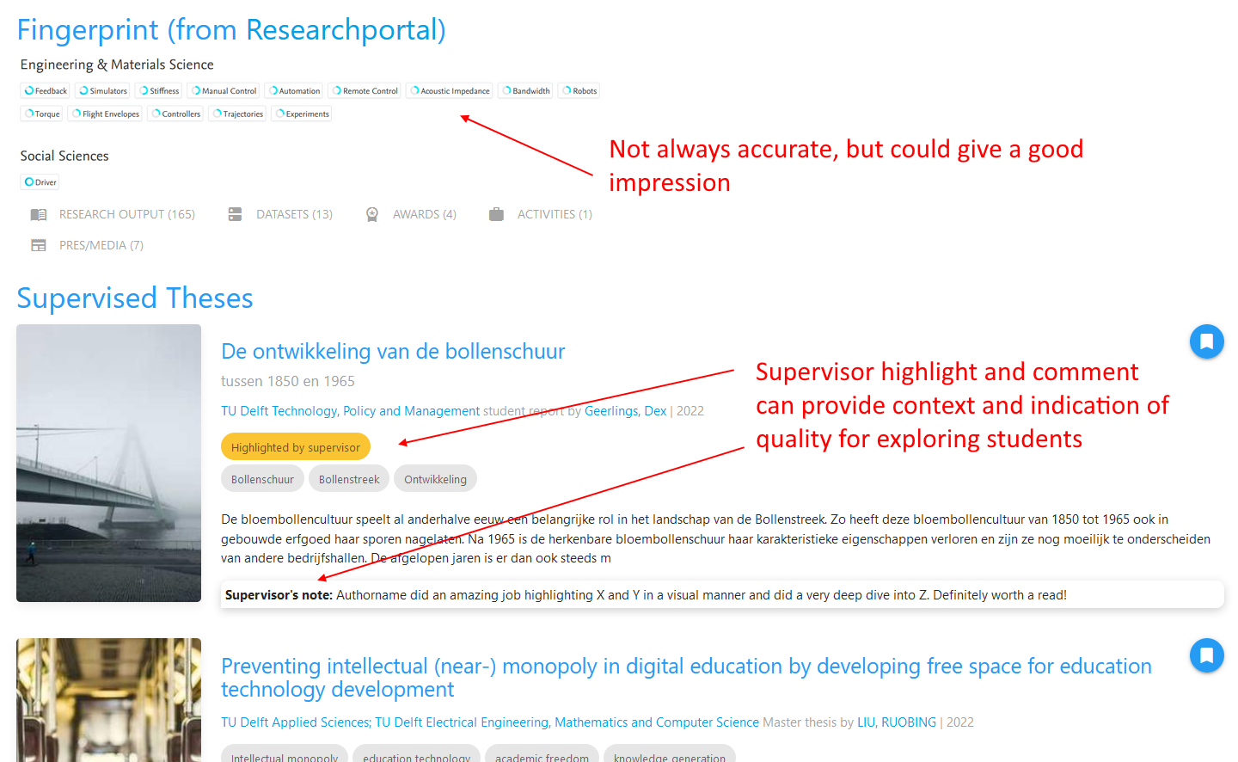

Programme page

The master programme page should be a jumping off point for orienting students. It can show the topics that come up quite often in the ‘often used keywords’ field; show a list of supervisors that often supervise for students of this master; and show recent, trending, and popular thesis that have come from this masters programme.
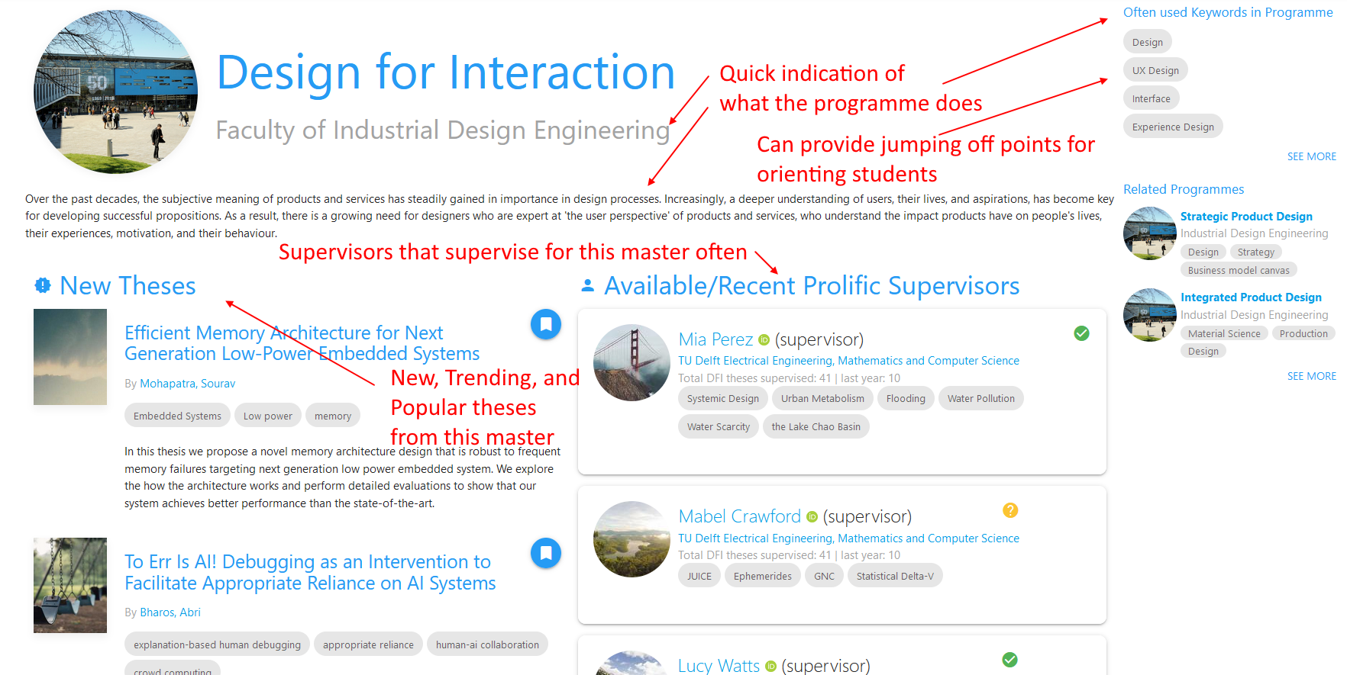
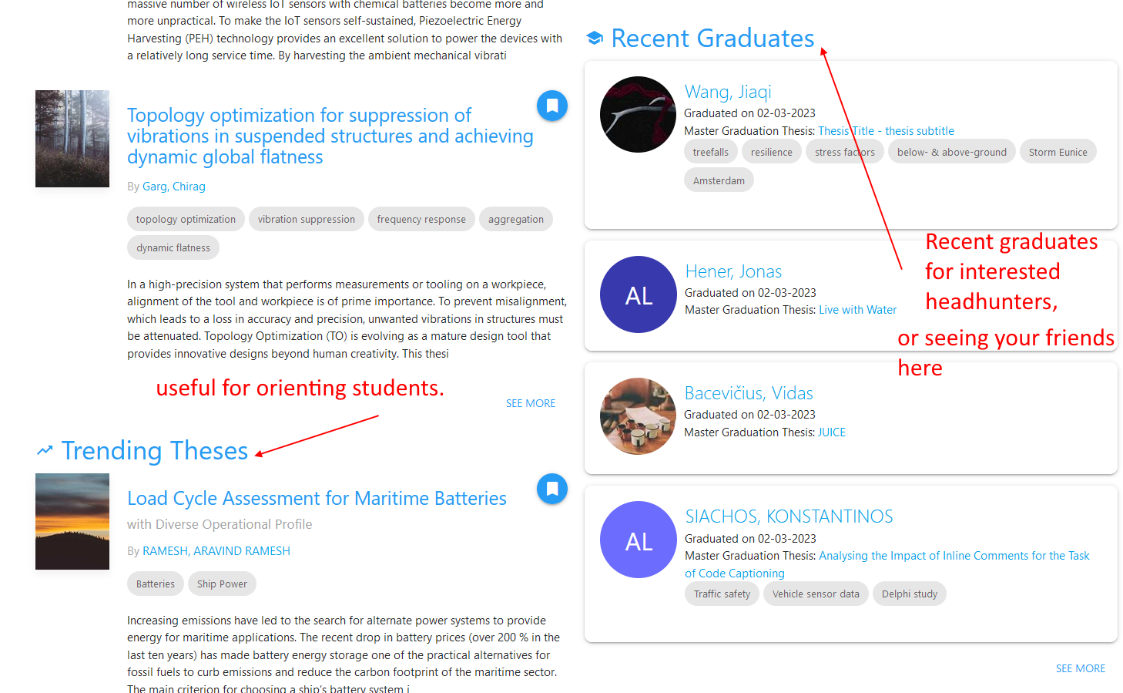

Keyword page

The keyword page is for people who are interested in a certain topic. It should show other theses with this topic, related keywords, and available supervisors who have experience with this topic.
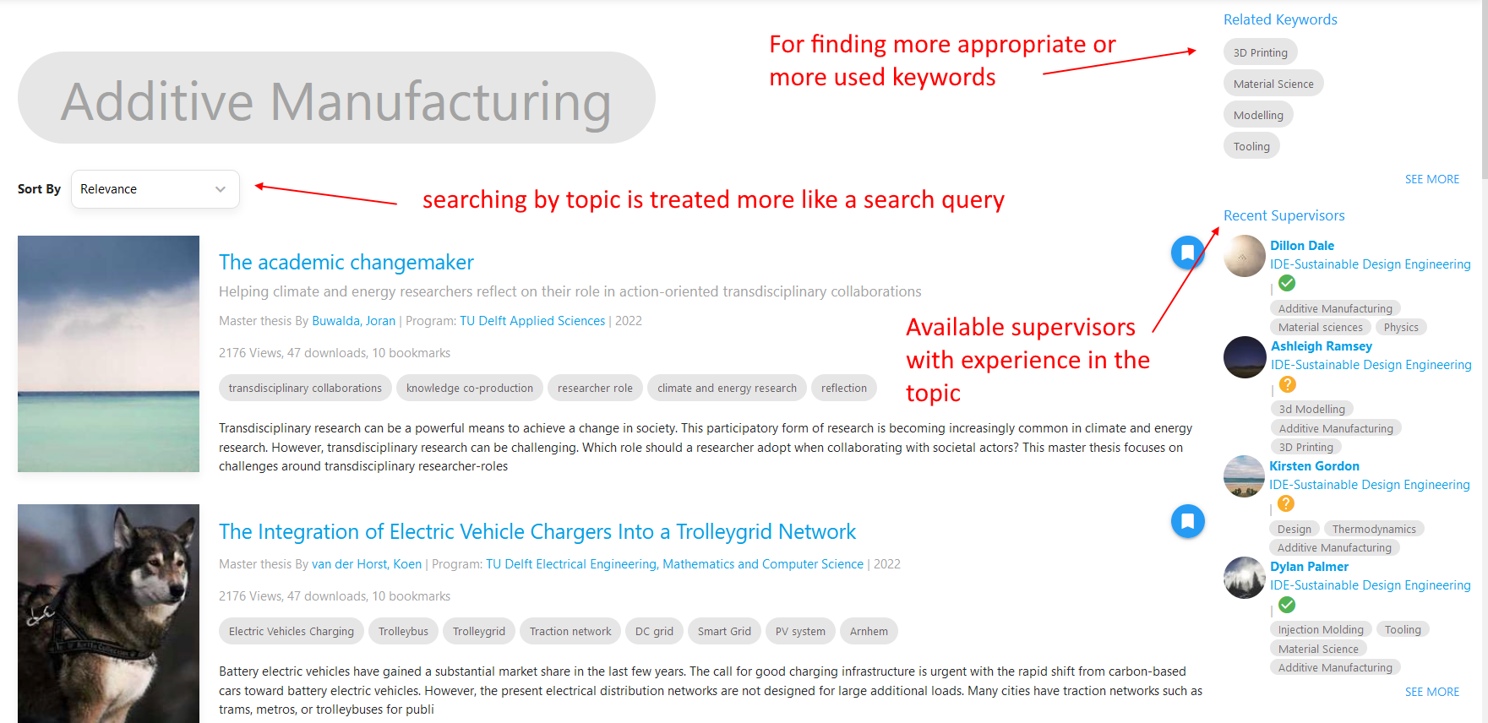

Upload page

The new upload page removes options that uploaders can’t or shouldn’t change anyway, and preloads the correct answer in the ones where it can guess the right one (If your NetID says your master is in DFI, it can preload DFI in the study programme field). It also has more help and explanation of the input fields, and the process behind the screens, which should alleviate a lot of anxiety in the uploaders. A lot of drag and drop upload fields have been added, which signal file support, and encourages users to upload different project files they already have on their harddrive.

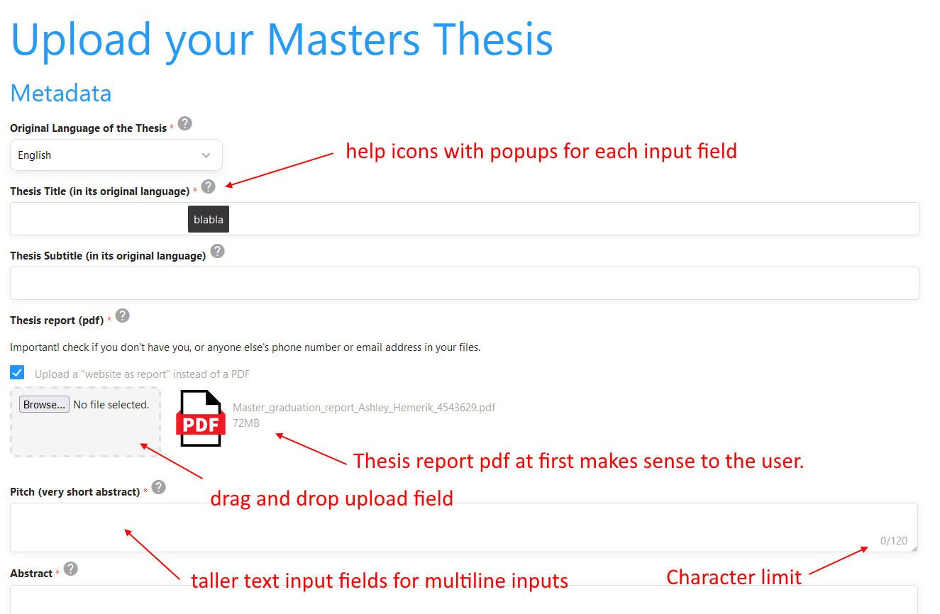
.

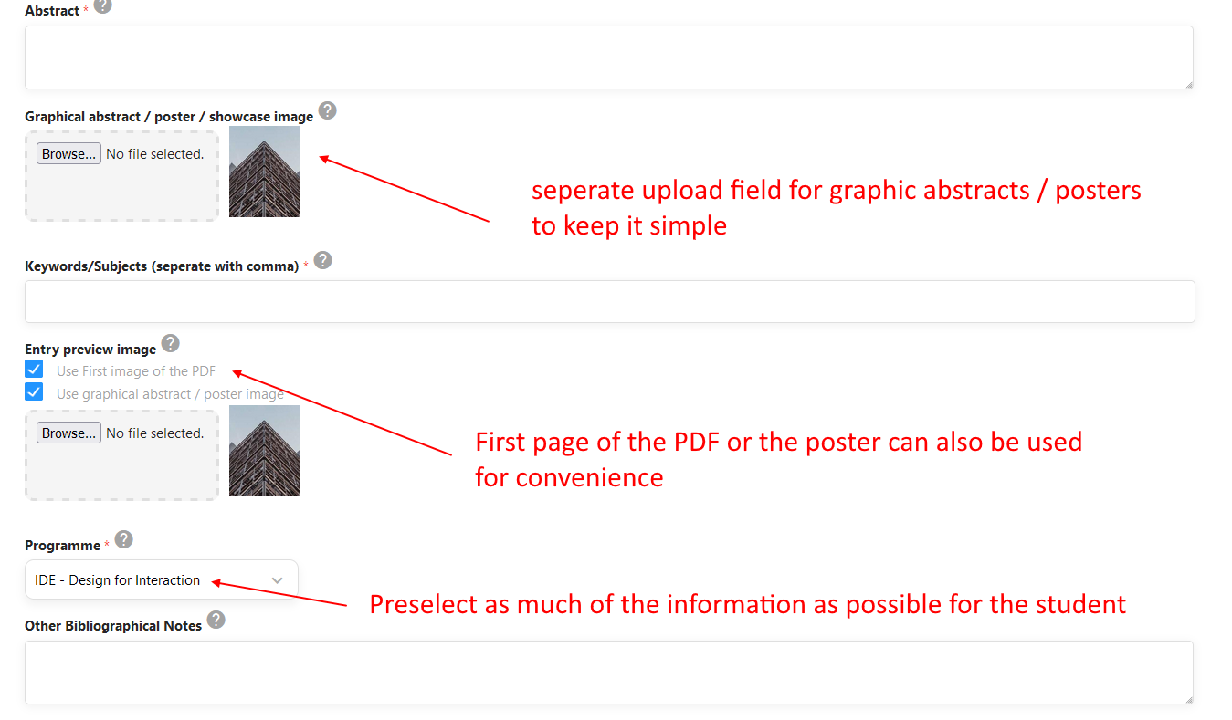
.

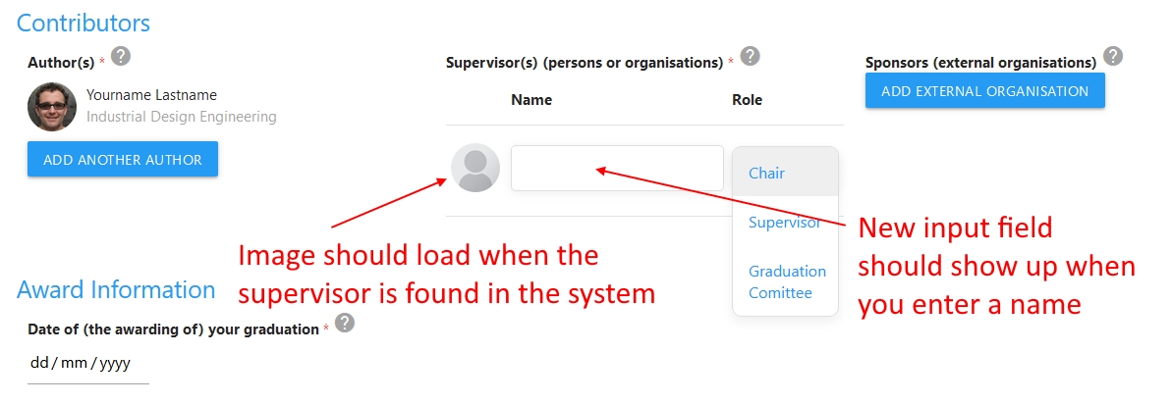
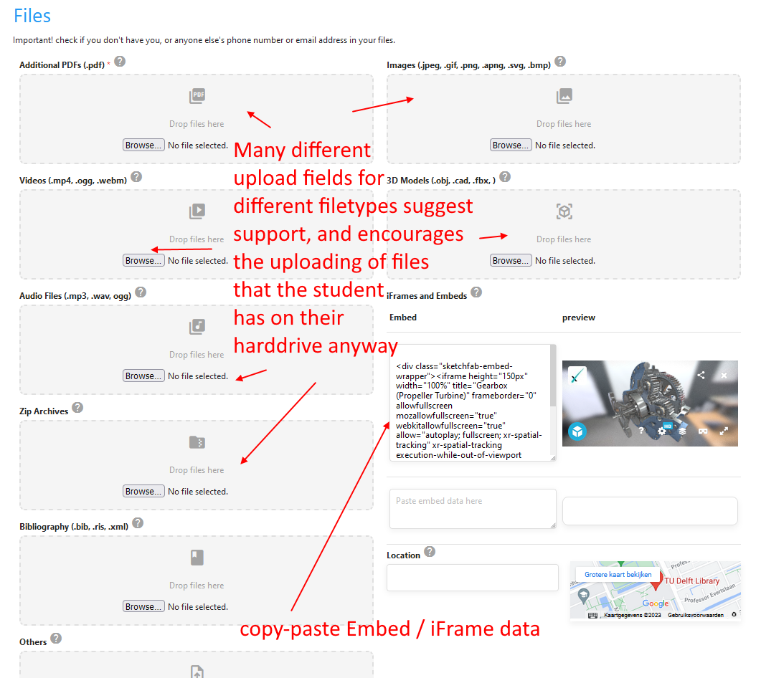
.

.

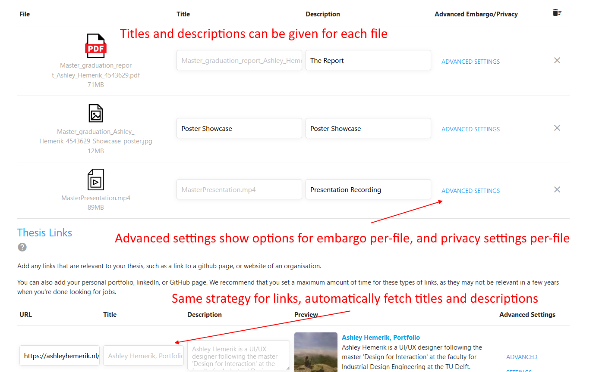
.
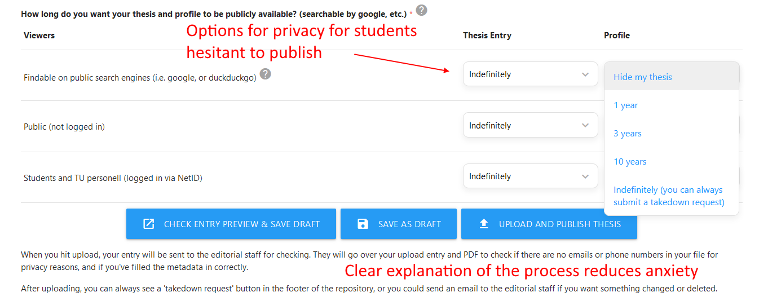

This image from the UK Home office shows nicely how to design for users with anxiety


